Methods

Data Analysis and Computational Methods

1. *In Vivo – Vitro Correlation (IVIVC)*

*In vivo* LNG blood plasma concentration results and *in vitro* cumulative LNG dissolution data were collected over periods of 581 and 297 days respectively with 50mg by weight and 28% LNG-loaded poly (PDL-co-DO) implants. [Using *in vitro* data from 100mg by weight and 28% LNG-loaded poly (PDL-co-DO) implants, and after adjusting with an scale factor to account for increased LNG mass, estimated *in vitro* data for the 50mg by weight polymer was extrapolated to 714 days.]

In both data sets, outliers were identified and ignored according to the Tukey’s Fences method (IQR rule) where *k* equals 1.5. To perform a Level A IVIVC analysis, *in vivo* data for all 9 samples were fitted to a single curve using the Curve Fitting Application in MATLAB (MATLAB and Curve Fitting Toolbox Release 2017b, The MathWorks, Inc., Natick, Massachusetts, United States) according to the following multiexponential equation [1]:



where Cp*(t)* is the concentration of LNG in the blood plasma at time *t*, *K*a is the absorption rate constant, *K*el the elimination rate constant, *a* is a constant representing the intercept of the concentration-time plot, and *b* represents a constant fitted by MATLAB to optimize the fitting of the graph. The Curve Fitting tool utilizes non-linear least squares regression analysis to best fit the observed data to the equation. The coefficients derived were then used as the values for *Kel* and *K*a.

The Wagner-Nelson deconvolution method was then applied using MATLAB, assuming a one compartment model, to obtain the fraction of LNG absorbed from the *in* vivo plasma concentration curve. The following equation was used for each assayed time point [2]:



Where C*a*(*t*) is the fraction of LNG absorbed at time *t*, Cp(*t*) is the concentration of LNG in the blood plasma at time *t,* and tmax is the theoretical time when all the drug has been released. LNG percentage released *in vitro* were calculated from the cumulative dissolution curves for all 4 samples and averaged.

The *in vivo* absorption percentages were plotted against *in vitro* average release percentages and a linear regression line was fitted. To determine the strength of a Level A IVIVC, a Pearson correlation coefficient and a coefficient of determination (R2) were calculated.

A Levy plot was also used to compare time points in the *in vivo* and *in vitro* data that absorbed or released similar percentages of LNG respectively. Time points with differences of less than or equal to 0.5% were selected and plotted. A linear regression line was then fitted and a Pearson correlation coefficient and a coefficient of determination (R2) were calculated.

1. *IVIVC Validation*

Predicted *in vivo* percentage absorbed values were obtained for each *in vitro* assayed time point using the linear regression IVIVC line fitted by MATLAB. The predicted *in vivo* absorbed values were then convoluted to give blood plasma concentrations using the following iterative equation [3]:



Where:



And Δ*t* equals the difference between two consecutive assayed time points (*t +1)* and (*t*).

The resulting predicted LNG blood plasma concentration curve was then compared against the fitted multiexponential curve obtained in section 1 and a percentage error was calculated for each time point and averaged.

1. *Predictive Computational Methods*

*3.1 In Vivo Prediction by Superposition*

*In vitro* cumulative dissolution data for all 4 samples was averaged and converted to give the average mass of LNG released per day between each assayed time point. The following formula was then applied iteratively to each mass of drug released over time [4]:



where Δ*t* equals the difference between two consecutive assayed time points (*t +1)* and (*t*), and *M* is the mass of LNG at time *t.*

The total mass of drug estimated to be in the *in vivo* system for any time was calculated by adding the mass of LNG released daily over any time period with the remaining mass of drug from previous time points remaining according to the equation, in a similar manner to superposition. The predicted blood plasma concentration was thereby calculated according to the following equation [4]:



where *B* is the bioavailability of LNG (assumed to be 1), V*d* is the apparent volume of distribution of LNG, and W is the body weight (in the case of an arbitrary rat, estimated to be at 500g). The resulting plasma concentration release curve was then compared with the observed *in vivo* release and the fitted concentration model.

3.2 *In Vivo Prediction by Numerical Convolution*

Given that the dynamics of the system are assumed to be linear, linear systems theory enables *in vitro* dissolution-time profiles to computationally predict *in vivo* response. To do this, the *in vivo* and *in vitro* profiles must be converted from the time domain to the frequency domain. This enables multiplication and division to act as convolution and deconvolution respectively. A transfer function relating an input function to its causal output can be created in the frequency domain as the ratio of the output function to its corresponding input function. This transfer function must be created from a reference dosage form to enable prediction of *in vivo* plasma concentration for other formulations [5].

*In vivo* and *in vitro* data from the 50mg by weight and 28% LNG-loaded poly (PDL-co-DO) implants was selected as the reference formulation to create the transfer function. To convert any function from time space to frequency space, its Laplace Transform must be taken, as defined by:



Given its many similar properties, for the purposes of data analysis the Fourier transform of a function over time was used as the equivalent of its Laplace transform as demonstrated by [6]:

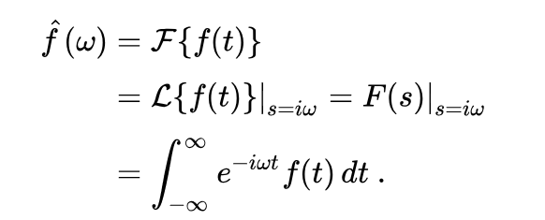

First the *in vitro* cumulative dissolution profile for the 28% LNG-loaded poly (PDL-co-DO) loading was fitted in MATLAB’s Curve Fitting Toolbox to a multiexponential equation of the form:



Fourier transforms were then taken of the fitted *in vivo* and *in vitro* profiles using MATLAB’s “Fast Fourier Transform” function. The transfer function was then calculated by the following equation in frequency space:



where ω is the frequency in Hertz, *T(ω)* is the transfer function, Cp(ω)r is the Fourier transform of the fitted reference *in vivo* LNG blood plasma concentration profile, and D(ω)r  is the Fourier transform of the fitted cumulative reference *in vitro* dissolution profile.

*In vitro* data from 50mg by weight and 27% LNG-loaded poly (PDL-co-DO) implants was selected and fitted according to the same exponential model as equation 8. The Fourier transform was then applied to the resulting equation. To yield the predicted *in vivo* response profile in frequency space, the *in vitro* Fourier transform was then multiplied by the transfer function in frequency space and by a scale factor *X.* This scale factor was used to adjust the magnitude of the transfer function to account for the difference in the actual amount of drug in the system compared with the reference formulation. This process is summarized by the following equation [5]:



where Cp(ω)Pred is the predicted *in vivo* LNG plasma concentration in frequency space, and D(ω)n  is the Fourier transform of the fitted cumulative *in vitro* dissolution profile for an *n*th formulation. Finally, the inverse Fourier transform was applied to the resulting function in MATLAB to yield the predicted plasma concentration profile in the time domain. The above process is summarised in appendix Figure B.

Methods 1-3.2 are summarised in appendix Figure A.

Results

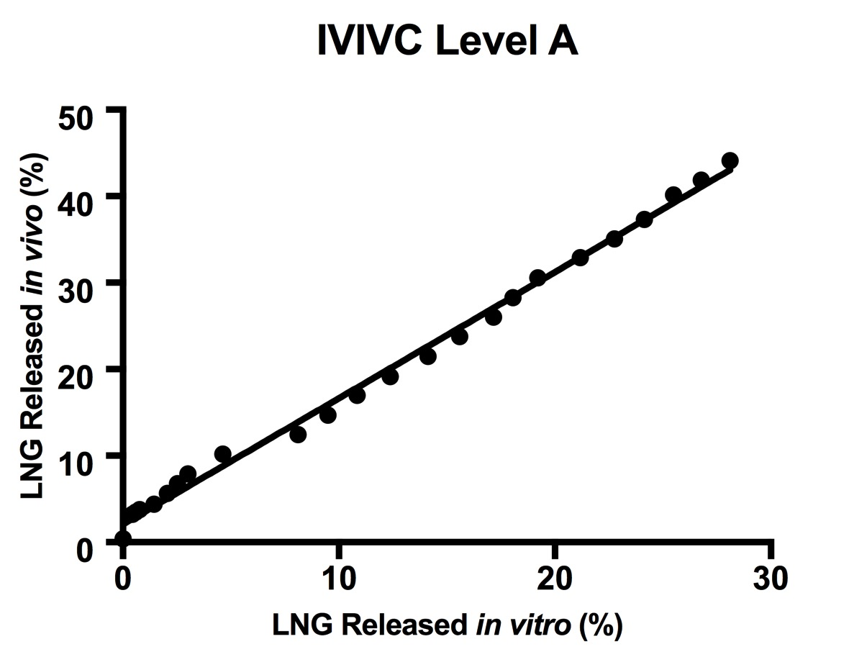

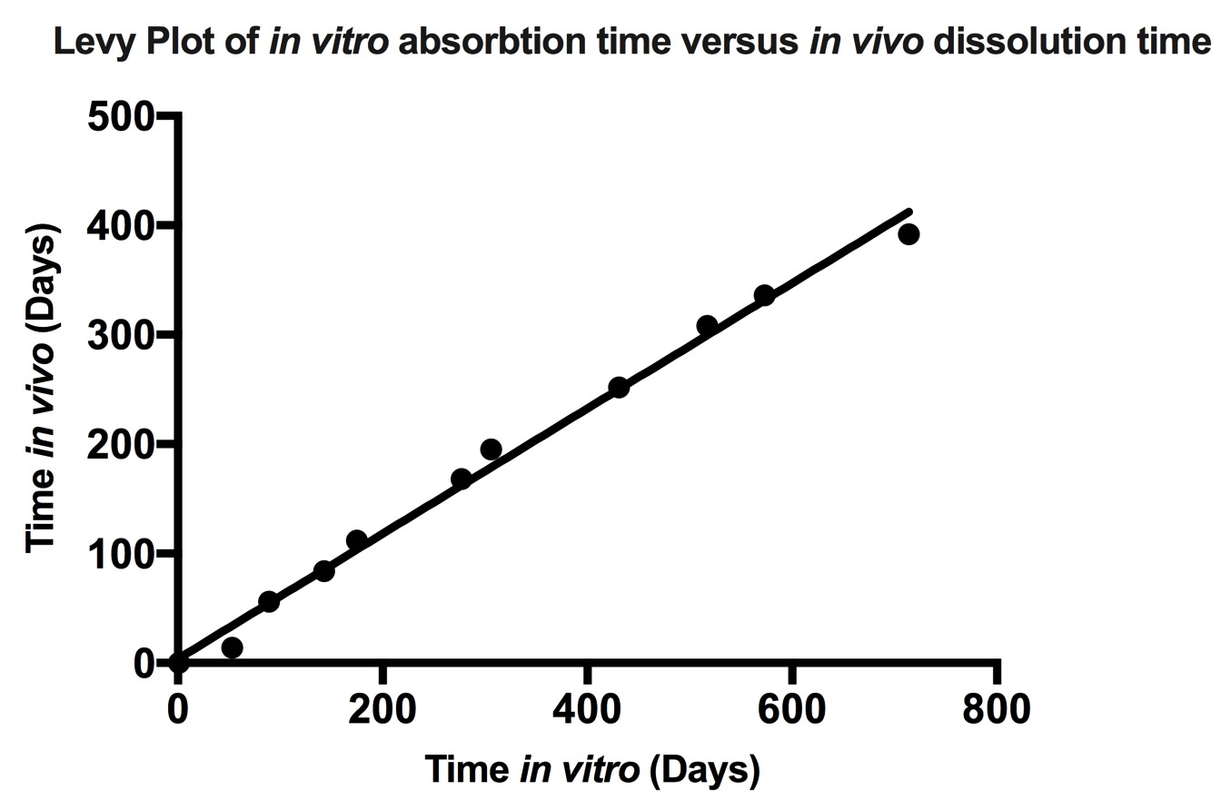

1. Validation

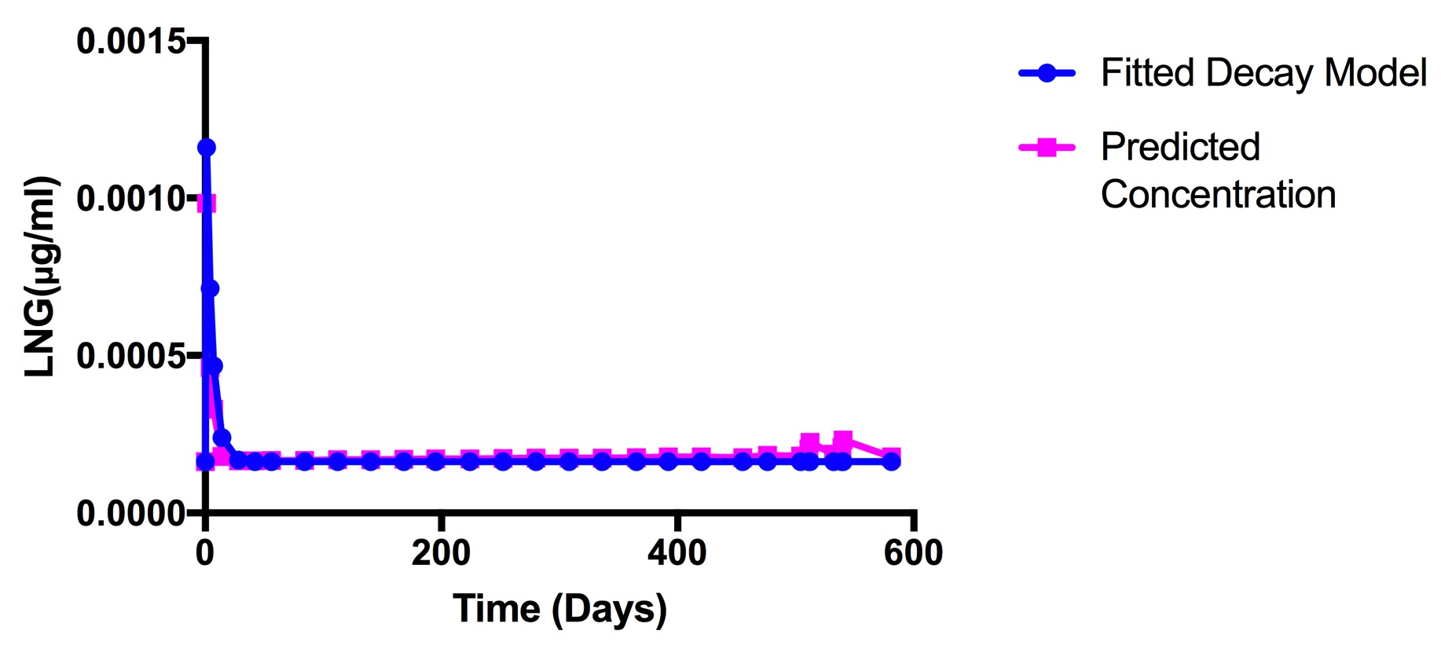

3.1 Superposition

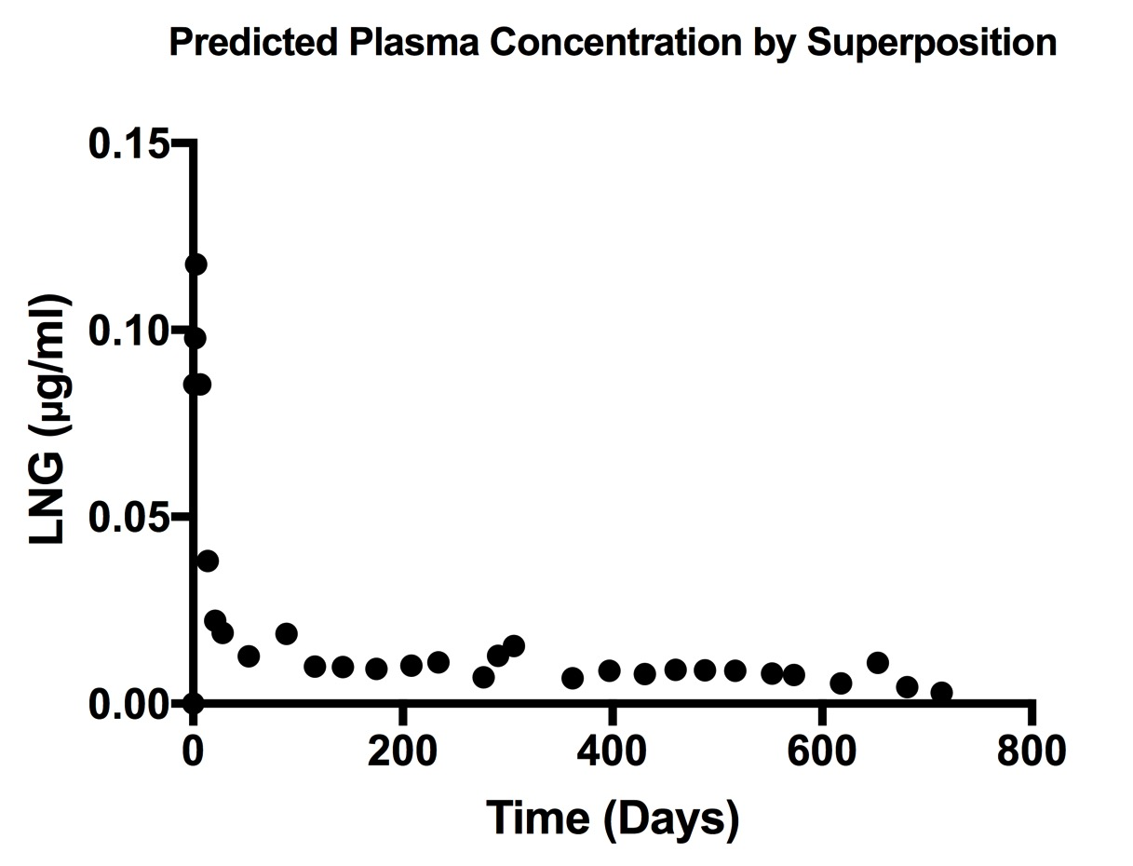

3.2 Numerical Convolution

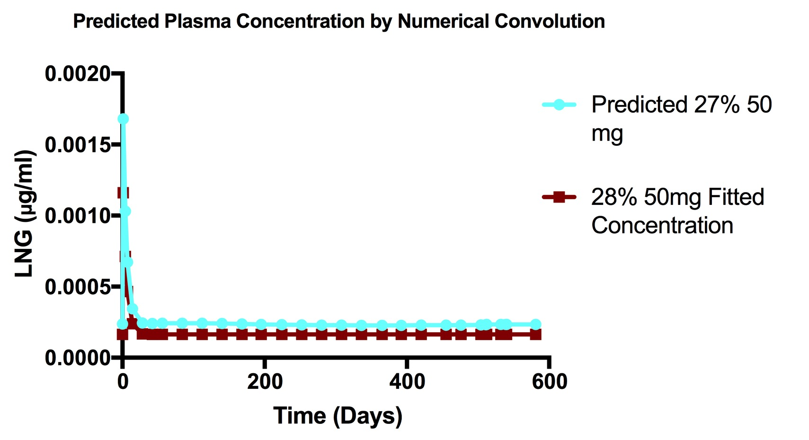

References:

1. Adapted from Jambhekar, Sunil S; Breen, Philip J, *Basic Pharmacokinetics,* Pharmaceutical Press, March 2012
2. Adapted from Margolskee, Alison et al. “Deconvolution and IVIVC: Exploring the Role of Rate-Limiting Conditions.” *The AAPS Journal* 18.2 (2016): 321–332.
3. Gohel, Mukesh et al., A Simplified Mathematical Approach for Back Calculation in Wagner-Nelson Method*. Pharmaceutical Reviews*, 2005
4. Qureshi, Saeed A., In Vitro-In Vivo Correlation (IVIVC) and Determining Drug Concentrations in Blood from Dissolution Testing – A Simple and Practical Approach, The Open Drug Delivery Journal, 2010, 4, 38-47
5. Adapted from Smolen VF and Erb RJ Predictive Conversion of In Vitro Drug Dissolution Data into In Vivo Drug Response versus Time Profiles Exemplified for Plasma Levels of Warfarin, *Journal of Pharmaceutical Sciences,* 1977
6. **Wikipedia Reference:** *Takacs, J., "Fourier amplitudok meghatarozasa operatorszamitassal", Magyar Hiradastechnika (in Hungarian), 1953*

Appendix:

Figure A: Flowchart scheme showing computational steps from 1-3.2:

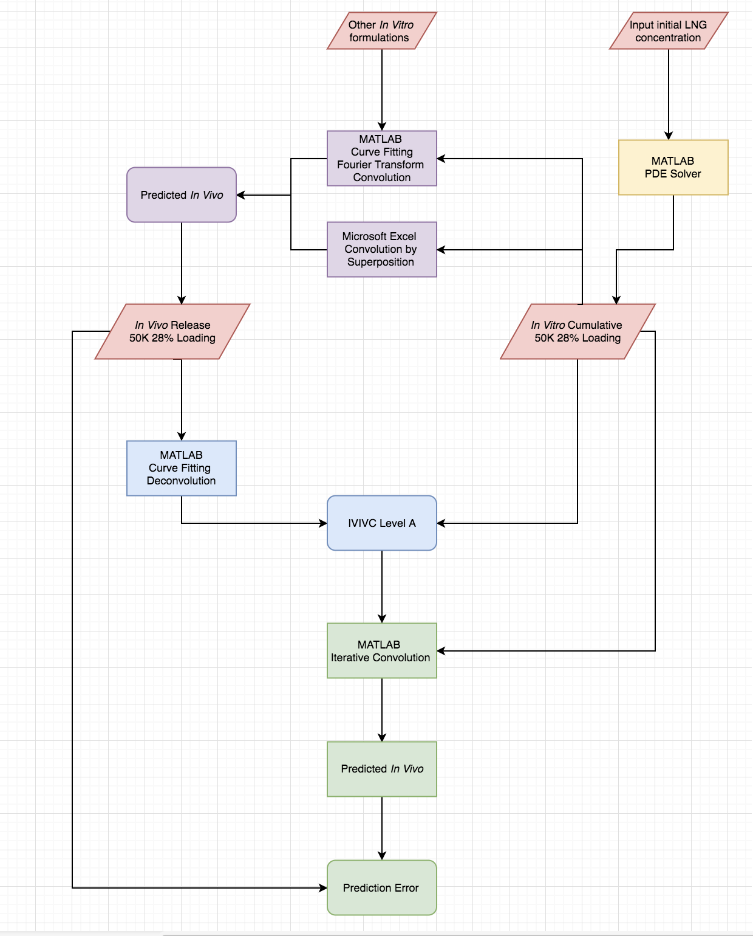

Red: Initial Data Green: IVIVC Validation Yellow: PDE Solver

Blue: IVIVC Purple: Computational Predictions

Figure B: scheme showing computational steps within 3.2[5]

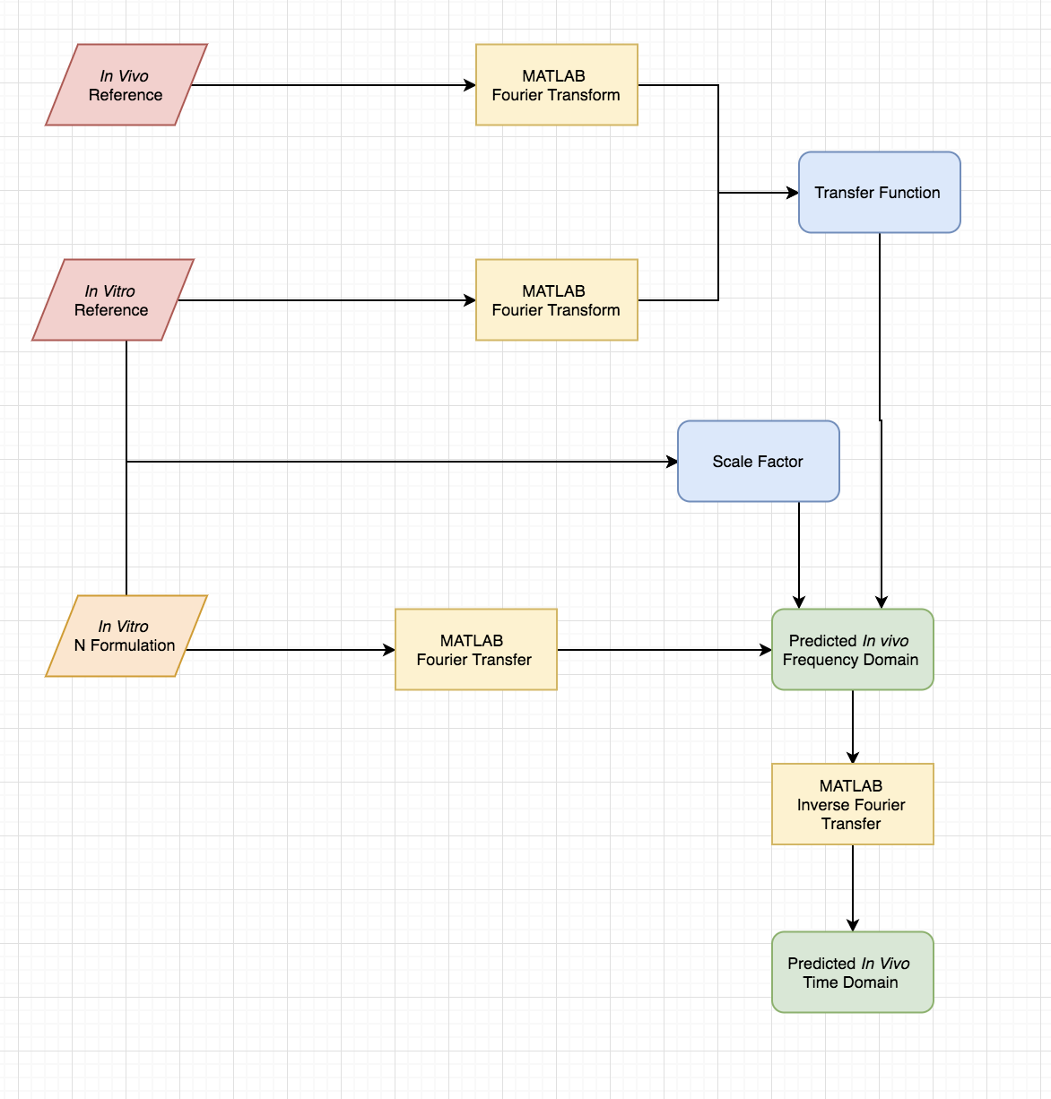

Red: Reference Data

Orange: Formulation Data

Yellow: MATLAB Fourier operations

Blue: Components of Prediction calculation

Green: Predicted Results